Eastern Goldfields CollegeMethods 2016

INVESTIGATION 2

In-Class Section

**TRIGONOMETRY GRAPHS**

**Name**:

***Score: out of 32***

*Maximum time permitted: 40 minutes*

For the In-Class section of this investigation you may use a calculator and the Out of Class version.

After the Out of Class section you should now understand the relevant transformations that can apply to trigonometrical graphs. This section tests your knowledge of this aspect.

1. Complete the table below for these *sine* graphs.

|  |  |  |  |  |  |  |
| --- | --- | --- | --- | --- | --- | --- |
| ***Rule*** | ***Period*** | ***Amplitude*** | ***Mean position*** | ***Maximum value*** | ***Minimum value*** | ***Horizontal shift*** |
| y = sin x | **2π** | **1** | **y = 0** | **1** | **-1** | **none** |
| y = -2 sin(3x) + 4 | …………  [1] | 2 | ………… | ………… | **2** | ………… |
| y = 2 – sin(x + ) | **2π** | ………… | ………… | **3** | ………… | ………… |
| …………………  [2] | **4π** | **5** | **y = 3** | ………… | 2 | **none** |

[7m]

1. For this graph state the
2. The period ……………… b) the amplitude ………….

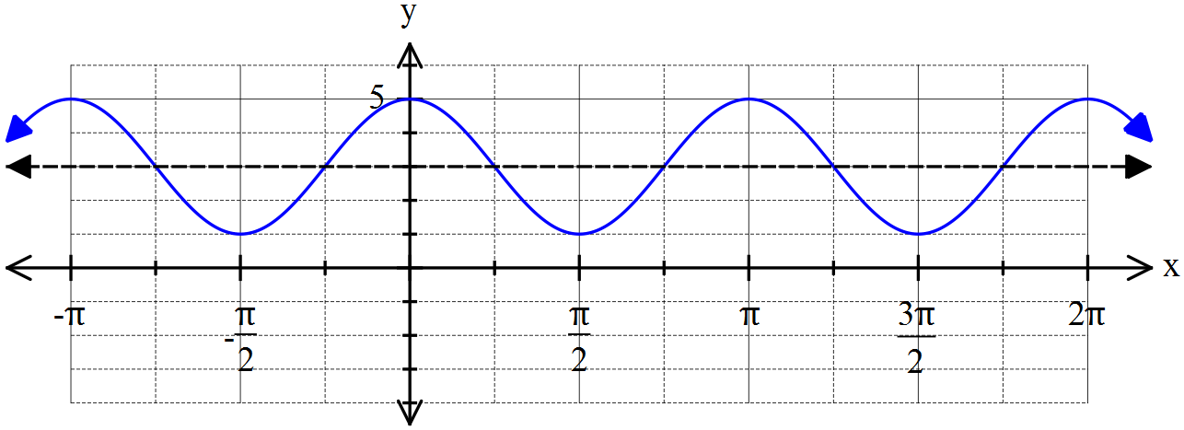

1. State the correct rule for this graph above. ………………………………………………………………

[1,1,2 = 4m]

1. Find the rule for this graph. ………………………………………..

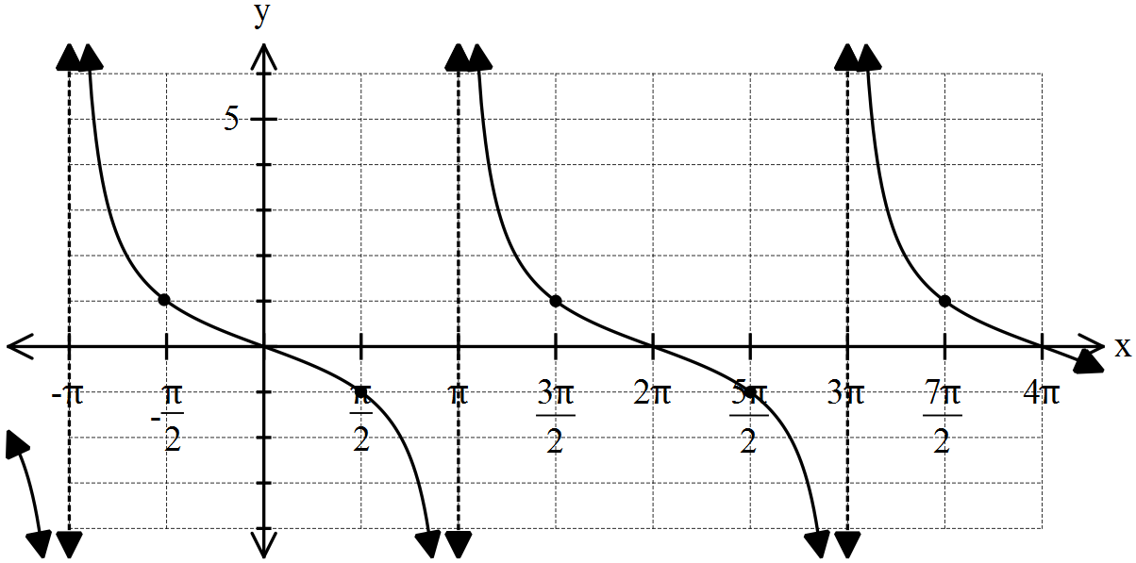

[2m]

3. A rabbit population on an island has been observed for a number of years and it has been found that the size of the population (in thousands) at the start of year t is given by:

 for .



(a) State the values of the constants A, B and C.

(b) Use your calculator to find the population at the start of the twelfth (12th) year, to the nearest 10 rabbits. Show working.

[3,3 = 6m]

4. You are the Captain of an oil tanker that needs to dock at the port of Charlotte Bay. Your navigator went crazy and jumped overboard 500 km out in the Indian Ocean, so it is your responsibility to get the ship in and out of port safely.

Your charts indicate that the rule for the depth of water in metres for Charlotte Bay today is

 where t is the number of hours after midnight.

(a) Use your calculator or knowledge to sketch a graph of the depth of water in the port, for a period of 24 hours.

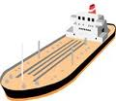

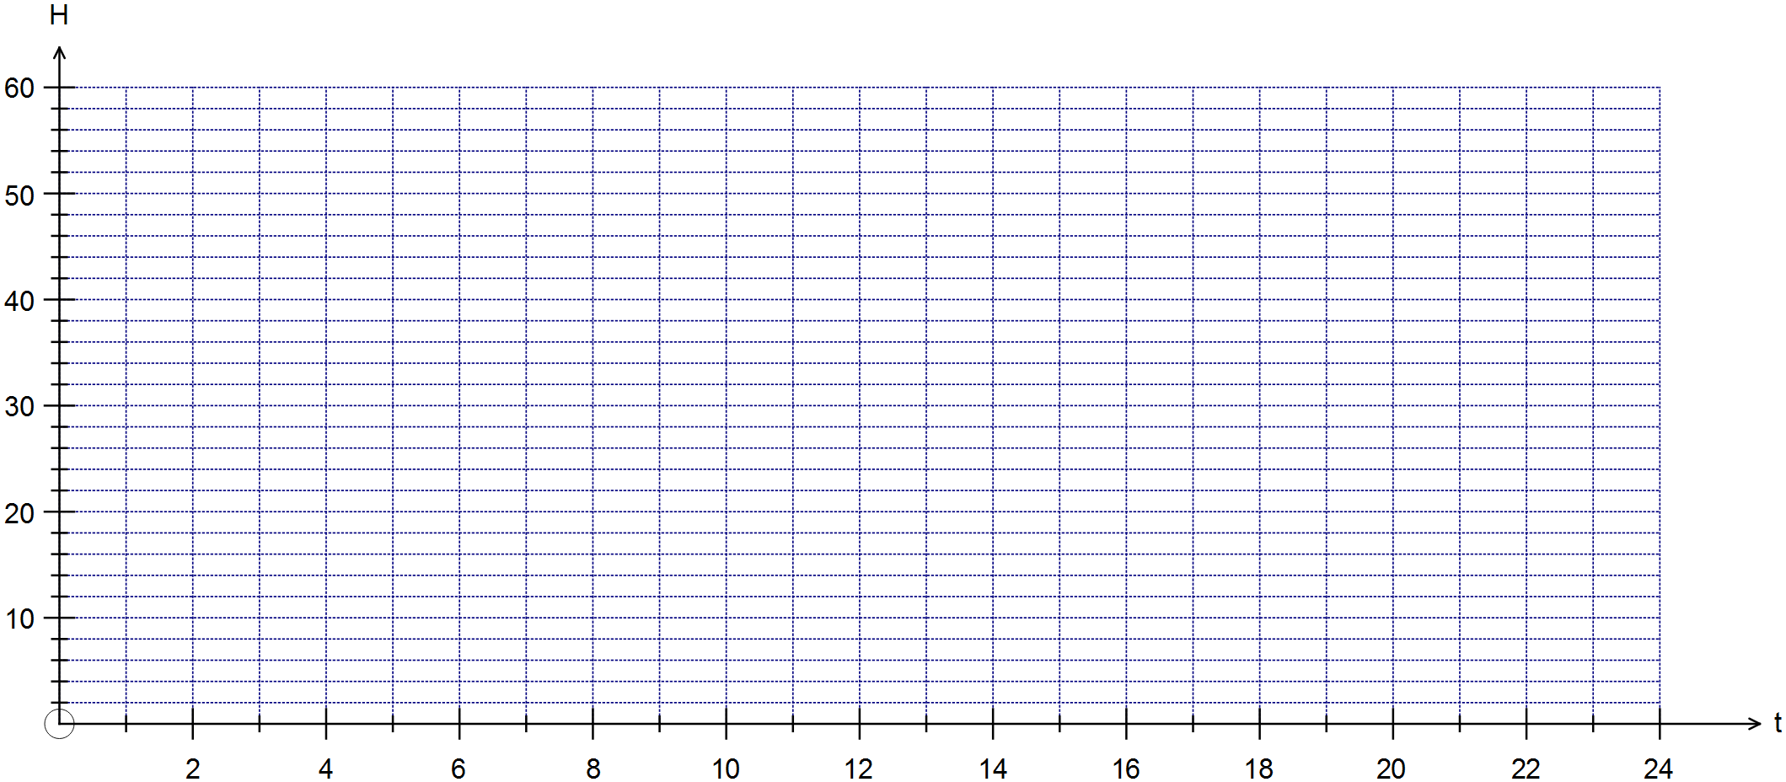

The tanker requires a depth of 35 metres or more of water in order to avoid being run aground.

1. Draw a line indicating the 35 metre water level.
2. Estimate the first time that you can enter the port.
3. Use your calculator to refine your answer to the nearest minute the first time that you can enter the port. Show working.
4. Find the maximum time that you can stay in the Charlotte Bay, until the water gets too low.

(To the nearest minute). Show working to justify your answer.

[2,1,1,2,3 = 9m]

5. You can combine sine and cosine graphs to produce a new graph.

For example y = 3 sin(x) + 4 cos (x) is shown below.

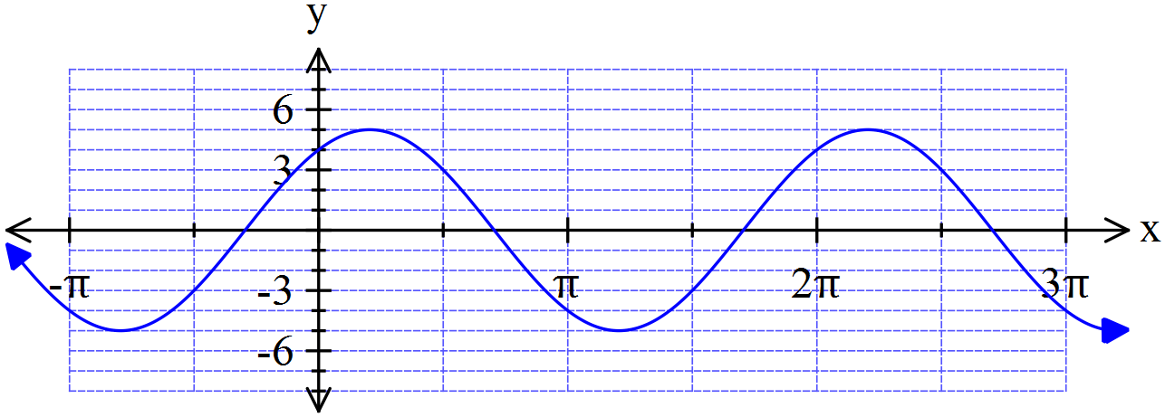

***y = 3 sin(x) + 4 cos (x)***

The combined rule y = 3 sin(x) + 4 cos (x) can be shortened to the form y = A sin (x – α) where α is known as the phase shift.

1. Note that A = .

Use your calculator or otherwise determine the value of the phase shift α (in radians to 4 decimal places) .

1. Given that α = in the example above express y = 13 sin(x – 0.3948) back to the form

y = a sin(x) + b sin (x). Indicate working.

[1,3 = 4m]